All Sufficiency – Part 1
Ron Bert

2nd Timothy 3:16
2nd Peter 1:3
Psalms 119:105
Psalms 119:130
Psalms 19:8
Acts 26:18
Psalms 119:99
Psalms 119:104
Romans 10:17
John 20:30
Jeremiah 23:29
Jeremiah 20:9
Luke 8:11
1st Peter 1:23
1st Corinthians 4:15
Isaiah 55:10-11
John 16:7-8
Acts 2:37
Romans 7:7
Psalms 19:7
Matthew 13:15
Revelation 3:20
John 6:44-45
Romans 1:16
“Ronald Bert” channel on YouTube
http://www.RonBert.com

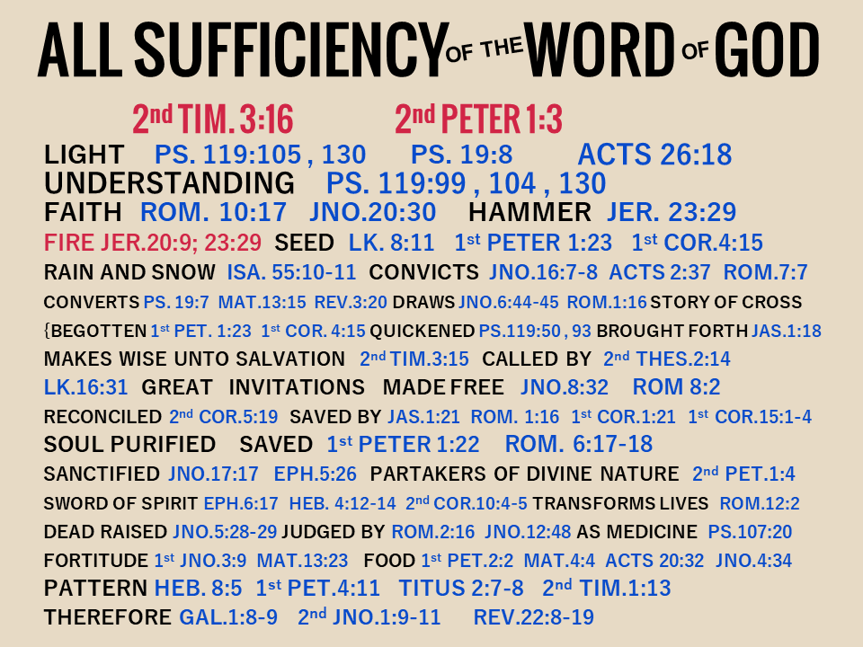

→ All scripture is to improve every facet of life
→ God’s light is our guiding path to a better life
→ His word allows us to see between good and evil
→ True faith comes by hearing the word of God
→ God’s word is the fire penetrating to the core of all
→ God plants His seed in us through His given word
→ God’s seed empowers those who eat of its’ fruit
→ God’s word convicts sin in His righteous judgment
→ Guilt is a sign to come to repentance
→ God’s word converts the soul to become wise
→ Healing comes through the heart as it understands
→ Jesus waits for each soul at the door to eternity
→ As it is written, God is our teacher in Christ

Eternity is the freedom God delivers to the faithful

All Sufficiency – Part 2
Ron Bert

1st Peter 1:23
1st Corinthians 4:15
Psalms 119:50
Psalms 119:93
James 1:18
2nd Timothy 3:15
2nd Thessalonians 2:14
Luke 16:31
John 8:32
Romans 8:2
2nd Corinthians 5:19
James 1:21
Romans 1:16
1st Corinthians 1:21
1st Corinthians 15:1-4
1st Peter 1:22
Romans 6:17-18
John 17:17
Ephesians 5:26
2nd Peter 1:4
Ephesians 6:17
Hebrews 4:12-14
2nd Corinthians 10:4-5
Romans 12:2
“Ronald Bert” channel on YouTube
http://www.RonBert.com

→ He calls for us to come out of the corruptible
→ God’s word comforts one during afflictions
→ God begets us with His own word of truth
→ The gospel call goes forth to come to Christ
→ Life in Christ frees us from the law of sin and death
→ It is receiving the word that is able to save our souls
→ God’s own sacrifice in Jesus allows us to stand
→ Obedience from the heart is devotion to God
→ God’s word washes our hearts and cleanses the soul
→ His promise renders an escape to a divine nature
→ God’s word moves the spirit and convicts the sinner
→ Virtuous weapons are maintained by God’s truth
→ Be renewed transformed into doing the will of God

Time reveals a heart’s image for God or not
All Sufficiency – Part 3
Ron Bert

John 5:28-29
Romans 2:16
John 12:48
Psalms 107:20
1st John 3:9
Matthew 13:23
1st Peter 2:2
Matthew 4:4
Acts 20:32
John 4:34
Hebrews 8:5
1st Peter 4:11
Titus 2:7-8
2nd Timothy 1:13
Galatians 1:8-9
2nd John 1:9-11
Revelation 22:8-9
Revelation 22:10-12
Revelation 22:13-15
Revelation 22:16-17
Revelation 22:18-19
“Ronald Bert” channel on YouTube
http://www.RonBert.com

→ A resurrection is coming, life for good, death for evil
→ The word of God will be judgment’s gauge
→ God’s own sacrifice protects the faithful seekers
→ Desire the nurturing word eagerly
→ Sanctified in His word builds an inheritance
→ To do the will of God is to finish the race
→ God wills we follow the pattern of good works
→ To change the doctrine of Christ is damning
→ Only those abiding in Jesus will find salvation
→ We are to worship God & no creation of His making
→ Blessing for all who obey His call to noble service
→ Jesus is the root of Spirit that pleas we Come
→ To hear and act on His word offers life in Him

In God life is more than exotic where angels live

